**Personal assistance for seniors who are self reliant**

ASSIGNMENT 1

IBM ( NALAIYA THIRAN)

TEAM LEADER: Shakeeb Jani Shanavas

REG NO: 510619106020

EMAIL: shakeebsharoo@gmail.com

TOPIC: SMART HOME

CIRCUIT DIAGRAM:

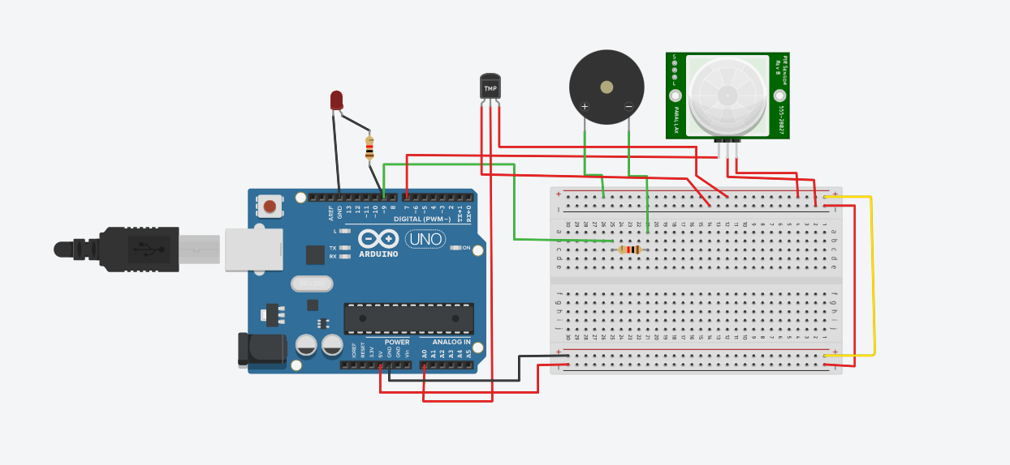

CODE:

const int buzzer = 9;

int sensePin = A0;

int sensorInput;

double temp;

#define pirPin 7

int calibrationTime = 30;

long unsigned int lowIn;

long unsigned int pause = 5000;

boolean lockLow = true;

boolean takeLowTime;

int PIRValue = 0;

void setup(){

Serial.begin(9600);

pinMode(pirPin, INPUT);

pinMode(buzzer, OUTPUT);

}

void loop(){

sensorInput = analogRead(A0);

temp = (double)sensorInput / 1024;

temp = temp * 5;

temp = temp-0.5 ;

temp = temp * 100;

if(temp > 60){

tone(buzzer, 1000);

delay(1000);

noTone(buzzer);

delay(1000);}

Serial.print("Current Temperature: ");

Serial.println(temp);

PIRSensor();

}

void PIRSensor() {

if(digitalRead(pirPin) == HIGH) {

Serial.print("Motion Detected");

tone(buzzer, 2000);

delay(1000);

noTone(buzzer);

delay(1000);}

}

OUTPUT:

